Valuing Human Capital
The case of refugees and migrants in Europe

Rosa Duvekot & Ruud Duvekot

Summary
The process of Validation of Prior Learning (VPL) is at the heart of making learning in all contexts and for any purpose worthwhile. VPL is a system that strengthens the role of the individual in shaping her lifelong learning. It can demonstrate the outcomes of learning in terms of profit (status, money), efficiency (time, customisation), and enjoyment. The learning-programme-independent nature of the assessment enhances the effects that VPL can create for personal objectives in terms of qualifications, career development and personal meaning. This paper looks at the impact of such VPL when implemented by higher education institutes (HEIs) for the sake of inclusion of refugees and migrants in their new country.

Introduction
Linking learning to social participation, inclusion and career-opportunities, and the changes in prevailing attitudes on learning are important themes that allow us to understand the current transition towards a (lifelong) learning society. In the ‘learning society’ everyone is encouraged to continue to learn throughout her life, whereas learning processes are supposed to be inclusive for all learners. In such a society the role of human capital is all the more important since steering development and sustainable utilisation of human capital is not just a matter of investment in continuous learning but becomes more and more a matter of self-steered ownership of the individual her- and himself. This phenomenon is all the more apparent when we analyse this transition on the personal level of higher educated refugees and migrants, integrating their human capital in a ‘new’ country.
Validation of Prior Learning (VPL) is at the heart of making the transition beneficial to all stakeholders. VPL focuses on recognising, valuing, validating and further developing the competences that someone previously learned. This entails instrumentation for recognizing and valuing what people have learned so far and linking this value to further development steps.
This paper looks at the impact of VPL implemented by higher education institutes (HEIs) for the sake of making HE-programmes accessible, therewith strengthening the inclusion of newcomers in their new country. The research is based on a case-study analysis of 43 in-depth case studies of ‘newcomers’ or migrants and refugees in Europe for the Erasmus⁺ project Validation for inclusion of new citizens in Europe (VINCE).

The Learning Society & VPL
The concept of ‘the learning society’ originated in the 1960s/70s. In this era there was a growing need for skilled labour. This led to more attention in national policies on the role of education in managing the rise in ‘social and economic wealth’. Education was equated with lifelong learning and a significant and relevant means of transforming social and political life for this purpose (Gelpi, 1985; Hobsbawm, 1994). This called for a learning society built on the notions that learning is important and valuable and that all people need to invest continuously in their potential. The UNESCO articulated this focus on learning in 1972 as follows:
If learning involves all of one's life, in the sense of both time-span and diversity, and all of society, [-] then we must go even further than the necessary overhaul of 'educational systems' until we reach the stage of a learning society. For these are the true proportions of the challenge education will be facing in the future. (Faure, et all, 1972, p. xxxiii)

In such a learning society, VPL acts as a connector for creating and facilitating lifelong learning by enabling learners to (1) validate their prior learning achievements and (2) create a further learning strategy when reflecting on this prior learning. VPL utilizes past learning experiences for creating new learning perspectives. VPL steers people’s empowerment with its focus on the freedom of choice and action to shape one’s life. This implies ownership of one’s learning and focuses on ‘the voice of the self’ when participating and negotiating with other actors in the learning arena on the why, how and what of further learning (Giddens, 1991; Narayan, 2005). Such empowerment challenges the existing education system and demands the design of flexible and tailor-made learning in any given context, for any purpose.
VPL strengthens the role of the individual in creating learning perspectives. It demonstrates the value of learning in terms of profit (status, money), efficiency (time, customisation), and enjoyment. The learning-programme-independent nature of assessment enhances the impact of VPL for various personal objectives: qualifications, career-steps, personal meaning, etc. (Duvekot, 2016). VPL is a process of five consecutive phases:
- Identification of an individual’s learning outcomes acquired through non-formal and informal learning.
- Documentation of an individual’s learning outcomes acquired through non-formal and informal learning.
- Assessment of an individual’s learning outcomes acquired through non-formal and informal learning.
- Certification of the results of the assessment of an individual’s learning outcomes acquired through non-formal and informal learning in the form of a qualification, or credits leading to a qualification, or in another form, as appropriate. (Cedefop, 2015, p. 14)
These four phases offer an outlook on learning strategies in which the organisation-context [labour market] and learning services of schools and universities are crucial for keeping up with the speed of individual capacitation and development. A fifth phase needs to be in place for VPL to establish its true promise:
- VPL follow-up entails activities in learning and working that enable the accredited, personal learning outcomes to be utilized for creating a variety of perspectives in the worlds of learning and working.
When affording VPL as a five phases-process, HEIs enable newcomers to create an open dialogue with university-staff on the nature and direction of further learning, taking into account the value of their prior learning.

Case-study analysis of countries and individuals
The case-study analysis investigates the phenomenon of inclusion of newcomers holistically from the top-down or system-perspective as well as the bottom-up or individual perspective. The system is analysed on country-level across Europe and input from 11 interviews with university staff; the analysis on individual level is based on 43 in-depth cases of migrants and refugees.
The focus is on higher-educated refugees and migrants since their human capital potential can be validated effectively due to the uniformity of higher education levels and standards across Europe on the one hand and the needs of Europe’s learning societies for a higher educated population on the other. The role of HEIs is not limited to helping refugees and migrants to better integrate into society; it also acts as a valuable platform for promoting social cohesion, solidarity, tolerance, diversity and human rights.
The main questions to be answered are how and to what extent is VPL facilitated across Europe in HEIs and how is this helpful for strengthening the inclusion of higher educated newcomers? The term ‘newcomer’ covers migrants within Europe and refugees coming from outside Europe. The impact-analysis centres on their learning-, career- and life-objectives in a new country. The objectives are getting better insights in the practice of VPL in higher education institutes, providing good practices and recommending on how to implement VPL for newcomers more effectively in Europe’s HEIs.

Country-analysis
Migrants and refugees are often prevented from enjoying their rights by legal and practical barriers. A main challenge these newcomers face is that, although they are often educated and skilled, their competences may not be recognised in the new country. Their skills and knowledge may not fit into predefined bureaucratic policies and procedures, documentation is lacking or their curriculum does not match certification structures in the host country. This hinders their access to the labour force and/or to continuing their studies, jeopardising their chances of fully integrating. In this perspective the VPL-process may help out.
The analysis of data on legislation, funding and facilities (information-provision, professional staff), favouring VPL as an entry-point for newcomers in HEIs from 37 country leads to a grouping of 4 prevailing country-systems in which the five phases of the VPL-process are applied, ranging from broadly applied to marginally or none:
The RED group, is countries having (1) a favourable national legal framework for applying VPL, (2) operationalised VPL in HEIs, taking care of prior formal, non-formal AND informal learning experiences, (3) funding on national AND sector and/or NGO levels and (4) opportunities for anchoring outcomes of VPL in career-perspectives in HE, labour market AND third sector. Group 1 is mainly situated in north and north-west Europe: Belgium, Denmark, Finland, France, Iceland, Luxemburg, Netherlands, Norway, Sweden and Switzerland.
The YELLOW group consists of countries having (1) a favourable national legal framework for applying VPL, (2) operationalised VPL in HEIs, taking care of prior formal, non-formal AND informal learning experiences, (3) funding on national OR sector and/or NGO levels and (4) opportunities for anchoring outcomes of VPL in two of the systems in HE, labour market OR third sector. Group 2 is spread across north-west, south and central Europe: Czech Republic, Germany, Ireland, Italy, Portugal, Spain, Turkey and United Kingdom.
The GREEN group holds countries having (1) a favourable national legal framework for applying VPL, (2) operationalised VPL in HEIs, only taking care of FORMAL prior learning experiences, (3) funding only on national level and (4) opportunities for anchoring VPL-outcomes to only one of the systems in HE, labour market OR third sector. Group 3 is Austria, Baltic States, Cyprus, Greece, Liechtenstein, Malta, Poland, Romania and Slovenia.
The BLUE group is countries having (1) no favourable national legal framework for applying VPL, (2) no operationalised VPL in HEIs, (3) no funding available whatsoever, and (4) no opportunities for anchoring outcomes of VPL any system in HE, labour market or third sector. Countries: Bulgaria, Croatia, Hungary, Slovakia and Russia.
VPL-application in European HEIs, 2017
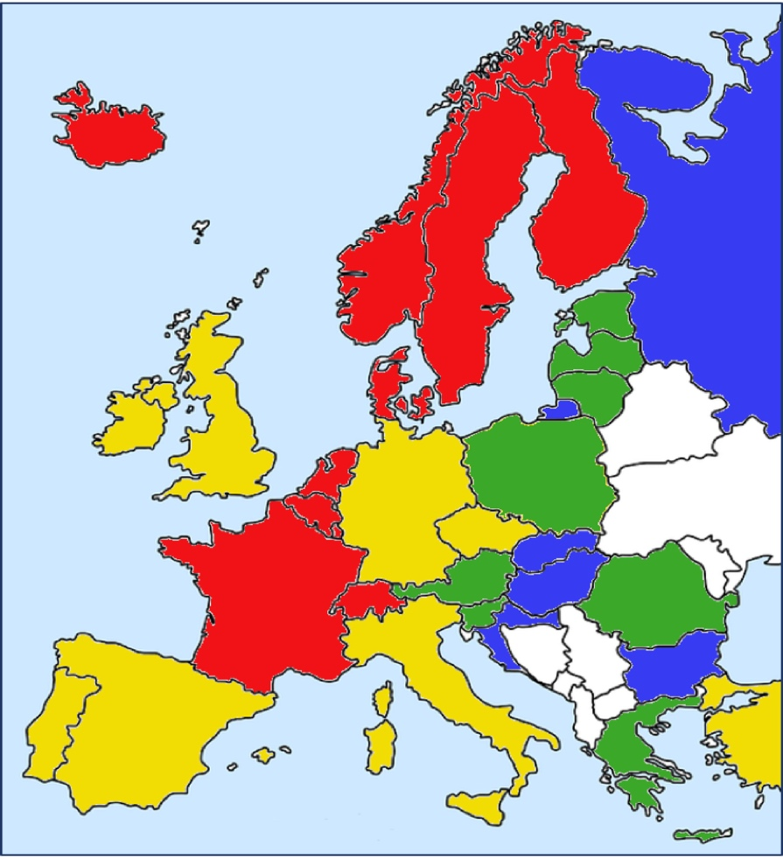
Duvekot & Duvekot, 2018.

Individual analysis
In total 43 individual cases of higher educated refugees and migrants were collected and analysed in 2017. Countries reporting were Austria (7 cases), Denmark (3), France (6), Germany (5), Greece (5), Hungary (2), Netherlands (10) and Norway (5). These newcomers experienced the VPL-process more or less in the same manner, seeking recognition, validation and accreditation for civil, social and/or personal perspectives in their new country.
On the personal level, the main analytical aspects coming to the fore were their agency, the affordance by HEIs, the importance of information and guidance, the impact of the consecutive VPL-phases and the ownership of one’s learning outcomes.
The individual case-analyses demonstrated that:
- Characteristics of policy development not only show the slowness of implementation in the practice of HEIs, but also that an open dialogue on the opportunities of HE is conducive to activation of the individual learner.
- Refugees and migrants are hesitant in accessing VPL-processes at first, but once informed, guided and reflective on their learning experiences, they clearly become empowered and engaged.
- Information provision on potential benefits of VPL is crucial for the agency of target groups. They feel ‘listened to’ and informally valued when helped in demonstrating their prior formal, non-formal and/or informal learning experiences. This encourages them to engage in participative actions.
- Newcomers profit likewise from VPL in terms of psychology (empowerment, self-esteem), educational attainment (exemptions, -if available – tailored learning) and career-perspectives (clarity about social opportunities, tuning in to the best fit in personal experiences + HE-qualification + career-options).
- They experience the same difficulties in formulating and proving their prior learning experiences as other students enrolling in HE. A main obstacle is the dominant learning paradigm in which people were educated and disciplined. Like European students, newcomers were educated in a monological education system in which the teacher is the knowledge-bearer and the pupil/student has to listen to the teacher’s voice. This holds back the student’s self-validation of personal learning experiences and isn’t helpful in creating a dialogue on learning in a VPL-steered process.
- Students taking time to reflect on their learning experiences strengthened their position in their dialogue on further learning with the HEI and/or employer. In most cases, the dialogue operated as a ‘gap-closer’ between the refugees/migrants and portfolio-trainer/teacher/employer; in this way, they managed to build a bridge to a personalised and tailored programme.
- The portfolio is the carrier of the VPL-process. Guidance or mentoring in the documentation phase is highly beneficial for newcomers.
- With the creation of a transparent portfolio of personal, prior learning experiences, the personal ownership of (lifelong) learning is enhanced. By articulating one’s learning achievements and reflecting on its value, by self-assessing one’s strengths and weaknesses (SWOT), self-efficacy becomes a driver for turning this retrospective ownership of learning into a dialogue for activating prospective learning opportunities.
- The supportive and facilitative role of NGOs is manifest, not only in funding VPL but also in providing information, guidance for VPL. NGOs also play a stimulating role in building up affordance of VPL in HEIs for newcomers, by networking and lobbying. Therewith they can play a decisive role in convincing HEIs to afford VPL-facilities for the target groups.
- The return on investment of a structured portfolio-training for preparation of a VPL-procedure is beneficial for newcomers. The same goes for language training and bridging courses (acculturation and additional competence development for solving knowledge deficits).
- Assessment helps to connect all actors in the process. This effect occurs in all forms of assessment that are analysed in the cases: assessment of, for and as learning, resp. summative, formative and reflective assessment.
- There is a real dynamic space between the system (top-down) and the process (bottom-up), but depending on the intended learning objective, results are always obtained for different actors. If the system is in control, due to an inside-out approach, it is mainly the organisation and ‘the university’ that benefit; if the process is prioritised in an outside-in approach, then the learner benefits.

Conclusions
VPL is acknowledged for opening learning opportunities for newcomers by recognising and valuing what they already learned. This analysis answers the questions of how and to what extent VPL is facilitated in Europe’s HEIs and how this enhances the newcomer’s inclusion. The main conclusions are fourfold.
Information-provision on VPL, including guidance services plays an important role in the utilisation of VPL by the target groups. Information and guidance are the so-called ‘front-office’ for raising awareness of the potential of people’s prior learning experiences on HE-levels. HE-staff needs to be well-trained in guidance and to be able to overlook the integral process of VPL and further learning programming.
Responsibilities of all VPL-actors are linked to specific purposes for engaging in VPL-processes. Many objectives may occur in specific national or sector contexts, especially since the true impact of VPL lies in the combination of certification, strengthening one’s self-esteem and articulation of competence-needs of learners. In this way, all VPL-actors cooperate in a holistic way by interlinking each other’s objectives and responsibilities. In such a holistic ‘adventure’ all actors taking their responsibility and affording access to HE need to have an open mind to formal, non-formal and informal learning experiences This is important for creating impact of VPL on individual level. It entails giving ‘a voice to the learner’. This works out best if the learner can get a grip on social perspectives assisted by the VPL-process. Creating such perspective is, next to good-quality guidance and assessment, a critical success factor of VPL in HEIs.
The objectives and impact of VPL in HEIs are tied in with the four main rationales for integrating VPL in a specific national, sector or regional context: educational, employability, HRD and lifelong learning. The educational rationale in which obtaining exemptions for a partial or a full qualification prevails in most countries and regions. Next to that economically motivated usage of VPL on HE-levels that takes care of competence recognition and employability for career motives is a clear runner-up as main driver. The more socially engaged VPL is in fewer countries apparent but it’s a strong driver for governments to face the challenge of dealing with competent but unqualified or underqualified target groups in society. VPL for participative aims in the third or volunteering sector or the civil society is least practiced; only in the Netherlands, and the Scandinavian countries where it is utilised for recognising indigenous values of minority groups or for strengthening the quality in volunteering and civil society activities, there is a clear focus on this level for practicing VPL in HEIs.
The expertise of VPL staff (portfolio guides, advisors and assessors) is very important in achieving maximum awareness of the value of personal learning experiences when refugees/migrants reach out to HE-levels. Their instrumental expertise equals the importance of them in creating motivation and ambition for accessing/applying VPL in HEIs. Furthermore, the quality assurance of a VPL-system depends on the clear formulation of what the expertise of VPL-staff entails, how this expertise is learned and maintained and how staff-members are embedded and accepted in qualification systems and systems of human resources management systems on the labour market and in the third sector.

Recommendations
A number of recommendations or challenges to anchoring VPL in HEIs for refugees and migrants can be formulated when overlooking the conclusions based on the information provided in the country cases as well as the individual cases.
Moving from policy to practice is imperative to creating more inclusive HEI.s VPL is recognisable as a key component for the individual´s possibility to manage shifts in modern life in terms of lifelong learning and career-guidance. This is also the case for refugees and migrants trying to build up a career in a new country. To make VPL a core element in integration/participation in the new country, the individual needs information, guidance and counselling, emphasising both learning and work perspectives in order to secure longer term relevance and value for the individual.
Strengthening VPL-practice entails upscaling the investment in raising-awareness of the value of prior learning experiences, information-provision on VPL-services offered (information, guidance, assessment) and strengthening the linkage of national qualification standards and occupational standards and coordination between national stakeholders and HEIs.
The awareness of the value of a VPL-approach in HEIs focused on learner needs and taking account of the value of not only formal but also informal and non-formal learning results depends on the consensus among all actors (target-group representatives, information officers, assessors, guides, teachers) in VPL-processes in and around HEIs. The actors can support awareness and consensus. Moreover, any actor can help strengthen information-provision to the target groups by reaching out to them directly or indirectly to their representatives/spokesmen in their new country.
Critical aspect in all approaches of HEIs is the importance of engaging designated target groups by making VPL a personalised approach. People need to be able to articulate their learning experiences, identify their personal competences and link these competences to perspectives and roles in society. The learner’s voice therewith is more than the need of people to have their voices listened to but also need to articulate their own voice.
The learner’s voice highlights the need for ownership of learners and the ensuing inclusion of their preferences and possibilities – regarding settings, time, cost, progression – in the formulation of VPL-strategies and the execution of VPL-processes in HEIs. Good quality of guidance and assessment of the learner is essential in the VPL-process for including such individual ownership of learning experiences. The American Institute for Personalized Learning advocates in its educational services for schools and educators that:
The greatest gift to learners is to give them the tools, insights, and understanding necessary to be in charge of their own learning and lives. When learners understand how to channel their interest and curiosity, they gain the ability to motivate themselves. When learners begin to own their learning, they gain a prized possession to protect, build, and maintain for a lifetime. (Rickabaugh, 2012)
Successfully applying VPL holds in this way a promise of creating social and/or economic perspective for people that can be linked to their intrinsic values and agency. Bray and McClaskey (2015) perceive such personalisation as the next development in the learning system based on the engaged, self-managing, learning individual operating in a supportive network, all within the modern, learning society. The offer of a shortened, self-steered and flexible learning path for obtaining HE-levels is in this respect more than formalising personal learning experiences; it’s more an offer of personal empowerment in terms of strengthening life skills, incl. literacy and numeracy, and social participation in the learning society.
The expertise of portfolio guides, counsellors, advisors and assessors is very important in achieving maximum awareness of the value of personal learning, and creating motivation and ambition for VPL and learning/social opportunities in HEIs ánd society. HEIs should therefore invest in the creation and maintenance of occupational standards for VPL information-providers, -guides, -assessors and -managers. Even more, these standards should be linked to internal human resource management systems in HEIs and offer the chance for career-paths in HEIs for VPL-professionals.
Next to career-paths in VPL-professionalisms, HEIs could also invest in research-programmes for VPL in educational, social and economic domains. Research is needed into the added value of VPL, among other things focused on its economic, financial and social effects.
When achieving a specific outcome of VPL for HE-competent refugees and migrants, it is a critical success factor to offer actual social or economic perspective. Sector-based and regional VPL-practices present successes (Singh, 2015), especially if involved organisations/companies ensure that their formulation of demands for functions and activities on HE-levels is transparent. This strategy works especially well when focusing on tackling skills gaps or offering further learning paths.
As a follow-up on VPL-processes, tailored, further learning options need to be offered by HEIs. These options need to be flexible in order to boost people’s desire to keep on learning. The VPL approach benefits from optimising other forms of learning: other learning environments and forms of learning must be formulated and/or utilised more effectively, since the outcome of a VPL-process also shows which learning environment and/or form of learning is best for an individual. This may include (combinations of) work-based learning, mentoring/tutoring, self-steered learning, distance learning, peer-learning, and so on.
An open dialogue on validation and learning between the individual and the learning and/or working systems can be effective when the co-makership of the individual in shaping her own future is truly accepted and afforded (Duvekot, 2017). The subsequent open dialogue is able to connect - retrospectively - the learning history of higher educated refugees and migrants with - prospectively - what they still need to learn in their new country.
VPL can be a strong guiding vision ánd tool by affording an open dialogical process of validation and learning between the learner and the teacher/employer in both the validation as well as the learning process:
- In the validation process, the testing (summative) and advisory (formative) functions of validation in the dialogue between (the portfolio of) the learner and the (qualification standards of the) teacher and/or the (occupational standards of the) employer are used to recognize, value and accredit learning outcomes. The learner is assisted in this process by test forms that are product- or process-oriented. Process-oriented means that learning outcomes are assessed integrated and interlinked, whereas in product-oriented validation this is based on the value of the learning outcome in itself.
- The learning process aims at offering learning that cannot (yet) be realized through validation or of which the learner believes that this learning is desirable. This process is personalized in terms of content, form and meaning. The learner can have a say in the design of the personal learning trajectory within the framework of the study program. This goes as well for refugees and migrants as for any other learner.

Final words
The overall conclusion is that VPL still has a long way to go before it is embedded all over Europe’s HEIs. Good practices from Danish, Dutch, French and Norwegian HEIs demonstrate that much is possible in affording refugees and migrants when they need or want access to HE. Offering VPL as an open gateway for linking a person’s formally, informally and non-formally acquired competences to a HE-programme is one of the critical success factors in these practices. Furthermore, offering the remaining competences to be acquired after the assessment in a tailored and flexible learning path is the other critical success factor. Both critical success factors depend strongly upon the willingness and the ability to recognise the competences acquired ‘outside of academia’; that’s more a matter of ambassadorship of committed VPL-staff in HEIs, open mindedness and embracement of the dialogue of validation and learning than of assessment-methodology or interview-techniques.
Least of all, this analysis gives credits to Paolo Freire’s statement in the 1970s that learning needs to be addressed as a developmental and dialogical process of ‘action-reflection-praxis’ of ánd by people (i.e. teachers ánd learners). It should be an anti-depositary process, contrasting the traditional ‘banking-system’ (Freire, 1970). Such processes of dialogical validation and learning suit every learner, inclusive of refugees and migrant with prior learning experiences. With ‘banking’ Freire meant a process in which knowledge is directly transferred to learners with the teacher as the sole distributor of knowledge and the learner as the passive receiver of this knowledge. Instead of ‘banking’ the ground floor for learning can better be ‘portfolio-ing’, in which learning is based on personal, prior learning experiences and the self-management of recurring learning processes.

References
Bray, B. & McClaskey, K. (2015). Make learning personal. Thousand Oaks, Corwin.
Cedefop (2015). European Guidelines for validating non-formal and informal learning. Luxembourg, European Communities.
Duvekot, R. & Duvekot, R.C. (2018). Validation of non-formal and informal learning for higher educated refugees and migrants (a VINCE report). Houten, EC-VPL.
Duvekot, R.C. (2016). Leren Waarderen. Thesis. Houten, CL3S. [Valuing Learning. A study of VPL and personalised learning]
Duvekot, R.C. (2017). Als leren je hele leven omvat. Houten: CL3S & IA. [If learning involves all of your life. From lifelong learning to personalised learning]
Faure, E., Herrera, F., Kaddoura, A., Lopes, H., Petrovsky, A.V., Rahnema, M. & Champion Ward, F. (1972). Learning to be. The world of education today and tomorrow. Paris, UNESCO.
Freire, P. (1970). Pedagogy of the Oppressed. New York, Continuum.
Gelpi, E. (1985). Lifelong Education and International relations. New Hampshire, Croom Helm.
Giddens, A. (1991). Modernity and Self-Identity. Cambridge, Polity.
Hobsbawm, E. (1994). Age of Extremes. The short twentieth century 1914-1991. London, MJ.
Narayan, D. (ed.) (2005). Measuring Empowerment. Washington: The World Bank.
Rickabaugh, J.R. (2012). Learning Independence Continuum. Pewaukee, CESA.
Singh, M. (2015). Global perspectives on recognising non-formal and informal learning. Heidelberg/Hamburg, Springer/UIL.

Authors
Rosa Duvekot, MSc, is researcher for the European Centre Valuation Prior Learning (https://ec-vpl.nl) and autonomous film producer. She holds a master’s degree in Film Studies and Visual Culture (University of Antwerp, Belgium).
Ruud Duvekot, PhD, chairs the European Centre Valuation Prior Learning and is Associate Professor at Utrecht University of Applied Sciences. He holds a PhD at Utrecht University (the Netherlands). In his thesis he examined the impact of VPL on the shifting learning paradigm from top-down, education-steered learning to bottom-up steered, personalised learning.

‘She’ or ‘her’ also mean ‘he’, ‘his’ or him’.
http://vince.eucen.eu or https://ec-vpl.nl

